Spring rolls
Ingredients  1 carrot, grated  1/6 cabbage, finely shredded  Other vegetables to use:  50g beansprouts  1 spring onion, julienne sliced  ½ red pepper, julienne sliced  1 tbsp soy sauce  6 x 23cm/9in squares ready-made filo pastry | Equipment  Weighing scales, sieve, mixing bowl, baking tray, rolling pin, small bowl, chopping board, knife, fork.  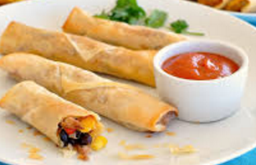

Method
- Preheat the oven to 220C/Gas 7. Line a baking tray with greaseproof paper.
- Prepare vegetables as described above.
- Mix the carrot, beansprouts, spring onion, red pepper and soy sauce together in a bowl.
- Lay a piece of filo pastry on the work surface.
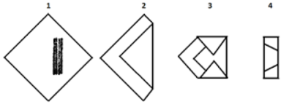
- Spoon one-quarter of the filling onto the corner nearest you. Fold this corner towards the centre and tuck it under the filling. Fold the two outside corners in towards the middle so it looks like an envelope. Then roll up the pastry to look like a sausage. Place on baking tray.
- Brush with oil, Repeat with the remaining mixture and pastry.
In Chinese cuisine, spring rolls are savoury rolls with cabbage and other vegetable fillings inside a wrapped cylinder shaped thin pastry. They are usually eaten during the Spring Festival in mainland China, hence the name. Traditional these would be deep fried but our lighter version uses filo pastry and is oven baked
- Bake in the oven for 15-20 minutes, or until crisp and golden-brown
Risk Assessment
Hazards | Rules to control hazards
Tripping over bags and chairs
Gas explosion
Bacteria getting into food
Burn from hot oven
Cuts from knives (Collecting, using and cleaning)
Slipping on food or wet floor

Evaluation:
Rating: (Circle) | Suitability for cafe | Likes/ Dislikes | Improvements

Spring Roll Worksheet

Suggest 4 different vegetables that could be used. Describe how they would be prepared.  1  2  3  4 | Vegetables are an excellent source of vitamin C and fibre in our diet. Why do we need these nutrients?
If this dish were served as a starter, what else could you serve in a 2 course meal. (Think about the eatwell guide) | What would be your top tips for using filo pastry?
Pastry can be difficult, time consuming and messy to make. A range of ready made pastries are available in the shops. Use the labels available to you to list these pastries below. For each type of pastry record a serving suggestion and the fat per 100g.
Type of pastry | Serving suggestions | Fat per 100g

Which pastry is the healthiest and why?

