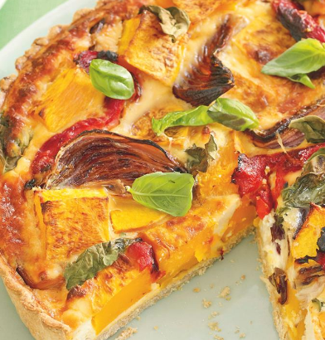
INGREDIENTS
Pastry:
150g plain flour (chilled)
75g butter or block margarine
3 tbsp cold water

METHOD
- Pre-heat the oven to 190°C / gas mark 5.
- Wash and dice vegetables. Mix with 1 tbsp oil and crushed garlic
and black pepper.
- Roast vegetables on a baking tray for 20 minutes, until turning brown and tender (caramelising).
- Make pastry: Sieve the flour into a bowl and add the fat.
Cut the fat into small cubes using a knife and rub lightly into flour using fingertips, until the mixture resembles breadcrumbs.
- Make a well in the middle of the mixture and stir in enough water using a knife, until a soft but not sticky pastry is formed.
- Wrap the pastry and rest (chill) the pastry until needed.
- Roll out into a circle to fit a greased flan dish. Ease into the corners.
- Part “blind” bake the pastry for 10 minutes: ( line the pastry case with baking paper, cover with baking beans or rice, bake for 10 mins.)
- Cut the bacon into small pieces with scissors. Grate the cheese.
- Put the bacon, cheese and roasted vegetables into the pastry case.
- Beat the eggs and milk and seasoning. Pour into the flan.
- Bake for 20-30 minutes until the egg is set.

SKILLS: Roasting/ Baking/ Blind baking/ rubbing in method for shortcrust pastry/ lining a flan dish/ vegetable preparation/ knife skills

Quiche – shortcrust pastry (6-8 portions)
Filling:
3 easy cook veg.. eg pepper, courgette, onion
1 clove garlic
150ml milk
2 eggs
50g bacon (lean trimmed)
100g cheese (edam or lower fat)
Salt and pepper
Equipment from home: Apron, tea towel, 20-25 cm oven proof flan dish
NUTRITION
Quiches can have a wide variety of filling that includes fish, other meat and a wide variety of vegetables such as broccoli and sweetcorn.

Using wholemeal flour increases fibre
Food science
Shortening: Rubbing the fat into the flour give the flour a waterproof coating so that gluten does not form when water is added. This gives the pastry a tender “short” texture
Caramelisation: Intrinsic sugar in the onion will start to caramelise when the vegetables are roasted
Coagulation: The filling will set in the oven because the protein in the eggs and cheese will coagulate.
Convection: Heating the oven
Conduction: The hot roasting tray heats the vegetables and the hot flan case bakes the pastry.
Variations: Try different vegetables, different cheeses eg stilton, oily fish such as salmon could be used

