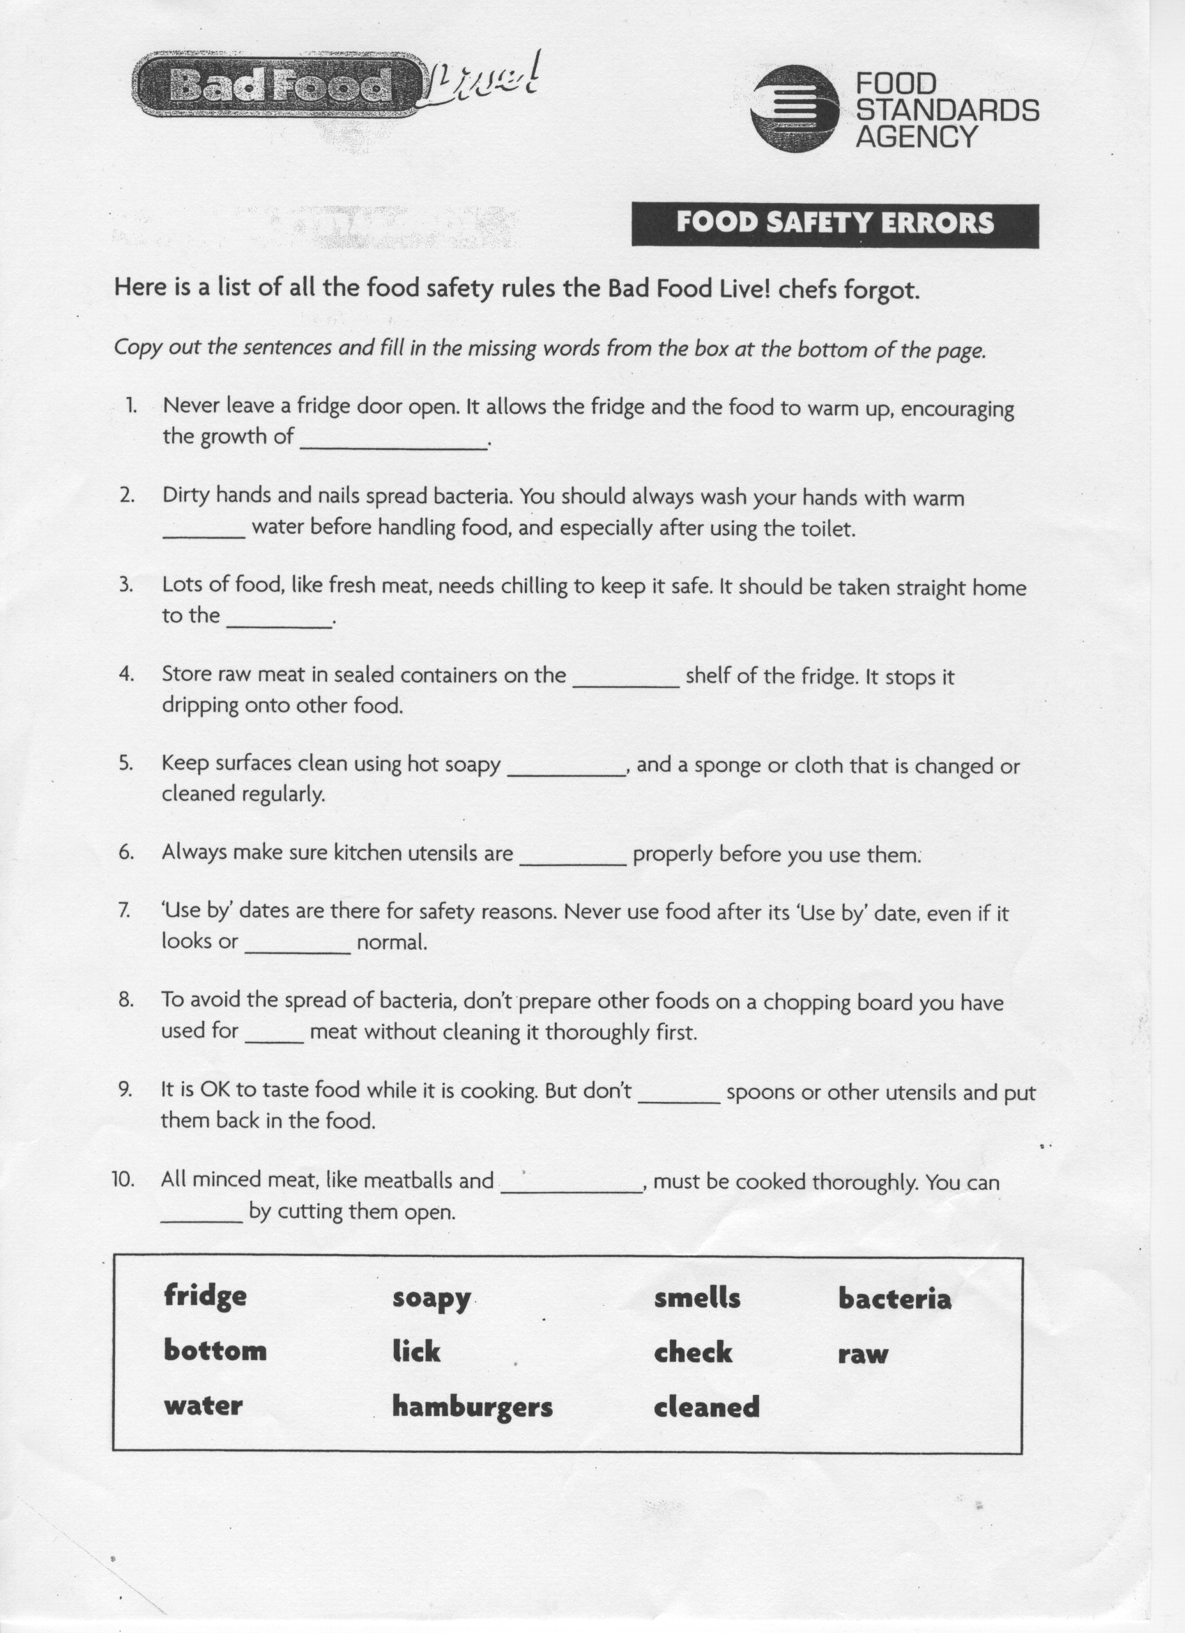
Watch the Bad Food Live videoon You Tube then complete the worksheet below.
Nuggets worksheet
The meat, fish, poultry and other protein foods section of the Eatwell guide provide protein needed for growth and repair of cells. Vegetarians do not eat meat. Circle the foods below that a vegetarian could eat:

Pork Beef Nuts Salmon Lentils Beans Chicken Egg Quorn Soya Lamb Milk
Raw meat contains food poisoning bacteria which are destroyed during cooking. It is crucial that this bacteria is not passed onto any salad or bread eaten with nuggets as these are not cooked before eating. This is known as cross contamination and is a big cause of food poisoning. Think about what you found out from the Bad Food live video and list 6 rules that would help prevent cross contamination of bacteria from raw meat onto other foods:

_______________________________________________________________________________________________________________________________________________________________________________________________________________________________________________________________________________________________

What could these chicken nuggets be eaten with to make a healthy meal, in line with the Eat well guide.

Find a large image of the Eatwell guide on the internet and label the sections of the guide below.

