AQA GCSE Food Preparation and Nutrition

NEA 2 35% of final GCSE

For NEA 2 you will produce a written assessment consisting of about 20 sides of A4 and a practical exam where you will make 3 dishes and their accompaniments in 3 hours to show a range of technical skill. Work will be marked as follows:

Section A: Research relevant to chosen task 6 marks

Section B: Skills trial of relevant dishes 18 marks

Section C: Choose and plan final menu 8 marks

Section D: Make in 3 hours 30 marks

Section E: Test, Analyse and Evaluate 8 marks

Total time is 20 hours/ Total marks are 70 marks

Photographic evidence with name and candidate number of all parts of the assessment is essential.

Important dates: (Write into your planner)

Start date: 23rd November 2017

|  |  |
| --- | --- |
| Work to be completed: | Finished by: |
| Research and skills trials | 2nd Feb 2018 |
| Planning of Task (Menu choice, reasons for choice, plan for making) | 23rd Feb 2018 |
| 3 hour practical exam | 26th or 27th Feb 2018 |
| Evaluating the task | 16th March 2018 |
| **FINAL HAND IN DEADLINE** | 16th March 2018 |

Also available on [www.keswickfood.weebly.com](http://www.keswickfood.weebly.com) and Shared>Secondary>Technology>GCSE Food Preparation and Nutrition > NEA 2

**Marking Criteria and Grade Boundaries**

**Investigation and Planning**

|  |  |  |  |  |  |  |  |  |  |  |  |  |  |  |
| --- | --- | --- | --- | --- | --- | --- | --- | --- | --- | --- | --- | --- | --- | --- |
| Please use the following as a guide to the lay out of your NEA 2.   |  |  | | --- | --- | | Titles and description | Feedback  🗸→ ? | | In exam user area open word and save as “NEA 2”  🗸 Insert Header with **Name and Candidate number**  **NEA Task 2 Outline:** Write your chosen task. Highlight the key words |  | | **Analysis of task and Research**  Analyse the task by explaining the research you might need to do  Carry out research related to the task  Identify a range of dishes that might be suitable for the task eg by mind-mapping, or using annotated images  Select and justify a range of technical skills to be used in the making of different dishes.  Remember to write a source for any info Eg (Source: Mrs M’s Nutrition lesson) (Source: www.bbc.co.uk/food) |  | | **Skills trials: (18 marks)**  Mind map all relevant ideas that meet the task.  Carry out 3 or 4 practical trials of a range of dishes from your mind map to showcase your skills. Write up each one with photo, skills shown and skill level, suitability to the task, quality of appearance, taste and texture. |  | | **Planning: (8 marks)**  **Choosing your menu:**  Now you must develop 3 dishes from your trials to make in your final 3 hour exam. You must not have made these dishes before. List your 3 chosen dishes as they would be shown on a menu with accompaniments.    **Reasons for choice: (**Explain why you have chosen the dishes you will make and what you will serve with them. Use Specialist Catering terminology where ever possible) Points to include ….  ***Practical Skills:*** *Explain the practical skill you will demonstrate. Explain if they are high, medium or low skill.*  ***Nutrition:*** *Explain how your meal meets the nutritional needs of the task and healthy eating.*  ***Ingredients available and food provenance:*** Local and seasonal foods and environmental issues  ***Equipment and cooking methods:*** *Explain how you can use labour saving/ quality improving equipment – such as a food processor, hand blender, food mixer, bread maker, pasta maker to make these dishes?*  ***Appearance, taste and texture:*** *Do the dishes balance in* ***colour, taste*** *and* ***texture?*** |  | | **Planning**  **Ingredients list** with weights and measures  **Timeplan** with order of work, predicted timings and quality and safety points |  | | **Evaluation:**  For each dish include:  Photo with labels to explain the dishes  **Acceptability of appearance, taste and texture**  Test and evaluate appearance, smell, taste and texture and your final dishes.  Add a star profile and have results from several testers. Add comments about your testers opinions.  Suggest improvements and developments to your meal.  **Nutrition evaluation**  Use Explore Food to do nutritional analysis of your final 3 dishes and comment on how well they meet healthy eating guidelines and nutritional needs of relevant groups  **Cost and portion size**  (Use the costing recipes information on shared area or [www.keswickfood.weebly.com](http://www.keswickfood.weebly.com) website)  Calculate cost per portion of your final dishes. Comment on how reasonable this is and how economies could be made.  Then add an overall comment about…  **Improvements** If you repeated the task again what improvements could you make.  Consider the actual dishes made in relation to nutrition, skills shown, finished appearance, taste and texture of results; time management; final presentation. Explain the reasons for the changes you have suggested.  Add comment on any other improvements that could be made to whole project. Consider research, planning and evaluation in this comment |  |   Bibliography: Write a list of sources your used. |

Mark Scheme

Researching the task (6marks)

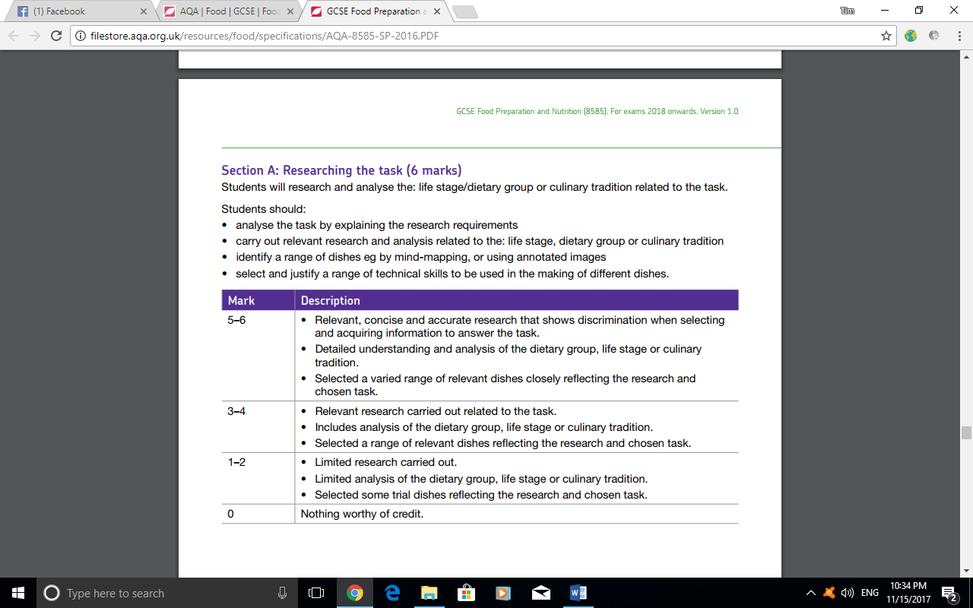

Skills trial (18 marks)

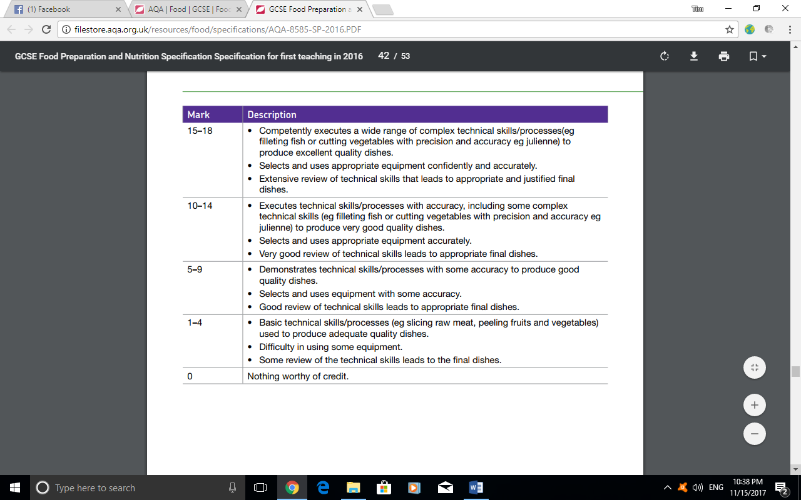

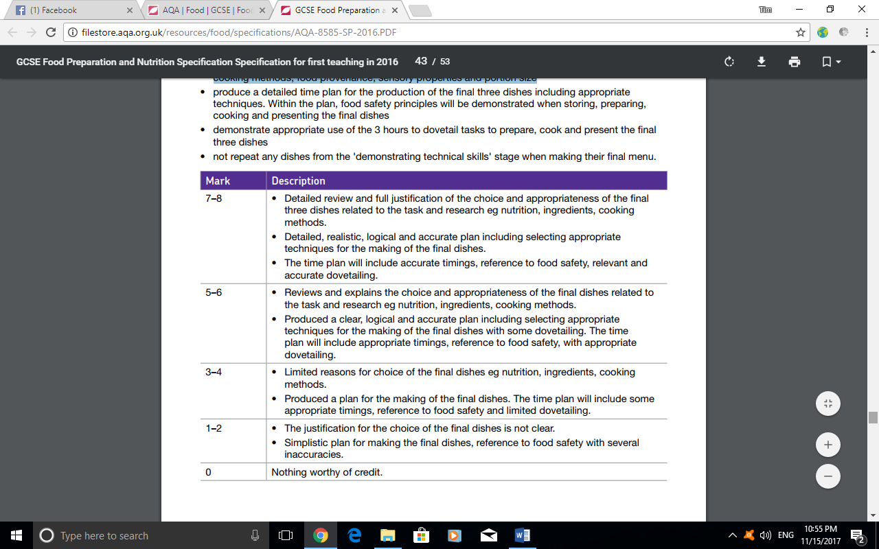Planning (8 marks)

Making (30marks)

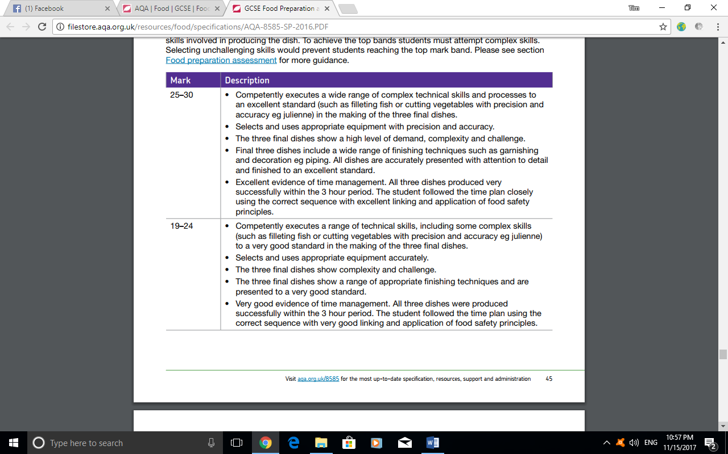

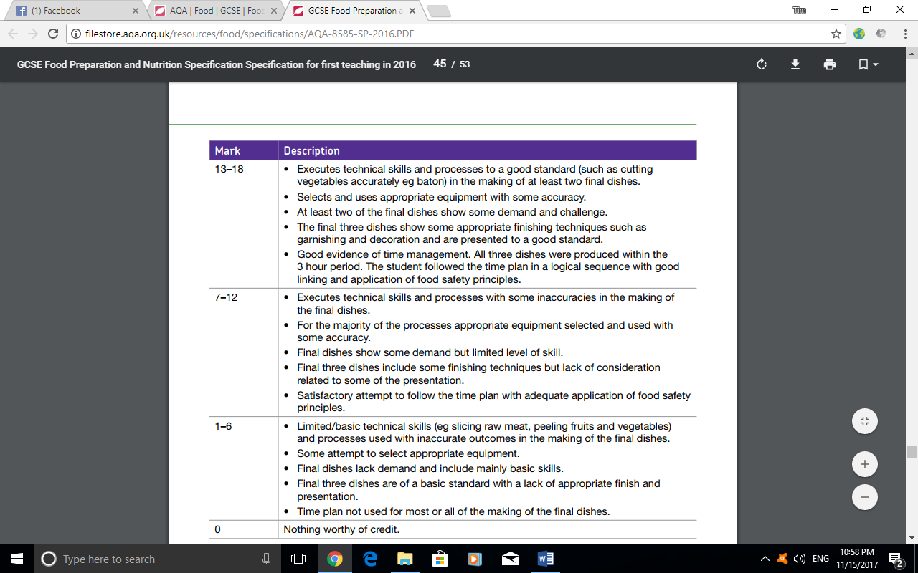

Analyse and evaluate (8 Marks)

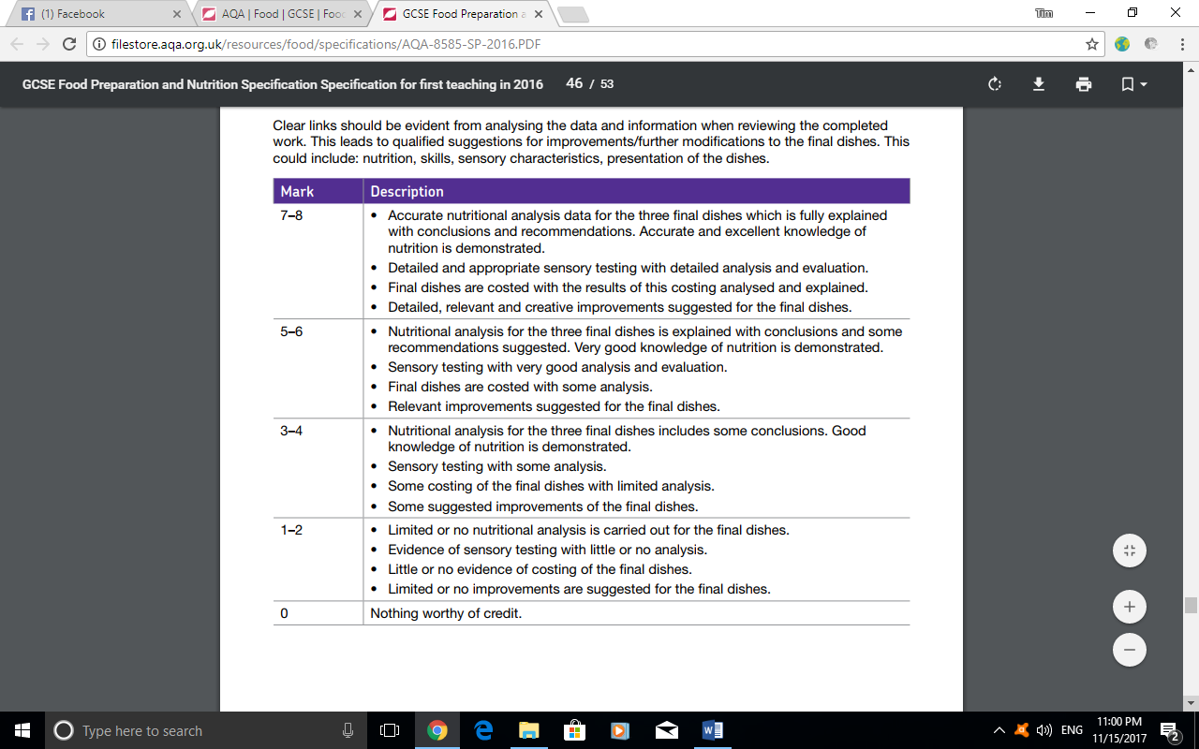

***Specialist* Terminology**

To get high band marks you need to show “*Very good use of terminology.*”

**Technical Terms**

Here are some technical terms that you should use in your written work:

|  |  |  |  |
| --- | --- | --- | --- |
| **Skills for Meat and Vegetables** | **Skills for Cakes and Biscuits** | **Types of Pastry** | **Types of Bread** |
| Chopping  Slicing  Dicing  Peeling  Grating  Julienne | Creaming  Rubbing-in  All–in-one  Melting  Whisking | Shortcrust  Flan/Biscuit  Crust  Flaky/Rough/Puff/Choux/Filo | Rolls  Pizza  Tortilla  Naan  Pitta |
| **General Skills** | **Decoration/Garnish** | **Types of Sauces** | **Desserts** |
| Weighing/Measuring  Shaping  Cutting  Rolling out  Folding  Beating  Sieving | Icing  Coating  Glazing  Piping  Feathering  Drizzling | Roux  All-in-one  Blended  Custard  Coulis | Whipping  Gelatine  Chilling  Freezing  Setting  Layering |
| **Methods of Cooking** |  | **Equipment** |  |
| Grilling  Oven  Baking  Roasting  Bain-marie  Hob  Boiling  Steaming  Poaching  Braising  Shallow frying  Deep frying  Stir frying  Microwave |  | Blender (hand)  Electric whisk  Food Processor  Liquidiser  Mill/Grinder  Pasta maker  Ice-cream maker  Rice cooker  Steamer  Electric wok  Zester  Temperature Probe |  |

**Key Terms**

**Mise en place** – Basic preparation prior to cooking.

**Accompaniments** – Items offered separately to main dish.

**Al dente** – Firm to the bite. Used to describe texture of pasta and vegetables.

**Au gratin** – Sprinkled with cheese or breadcrumbs and browned under the grill (e.g., fish pie, cauliflower cheese).

**Bain-marie** – A container of water to keep foods hot without fear of burning, or to cook something gently (e.g., lemon curd or melting chocolate).

**Brûlée** – Burned cream (e.g. Crème brûlée).

**Bouquet garni** – A small bundle of herbs. Used to flavour soups, stocks, stews or Bolognese sauce.

**Coulis** – Sauce made from fruit or vegetable puree (e.g., Raspberry coulis).

**Croutons** – Cubes of bread that are fried or grilled. Use to garnish soup or salads.

**En croute** – In a pastry case (e.g., salmon en croute).

**Entrée** – Main course.

**Flambé** – To cook with flame by burning away the alcohol (e.g., crepes Suzette).

**Garnish** – Served as part of the main item to make the dish more colourful and appealing.

**Marinade** – A richly spiced liquid used to give flavour and assist in tenderising meat and fish.

**Puree** – A smooth mixture made from food passed through a sieve.

**Reduce** – To concentrate a liquid by boiling or simmering (e.g., when making soups or sauces).

**Roux** – A thickening of cooked flour and fat. Used as the base of a white/béchamel sauce.

**Sauté** – Tossed in hot fat.

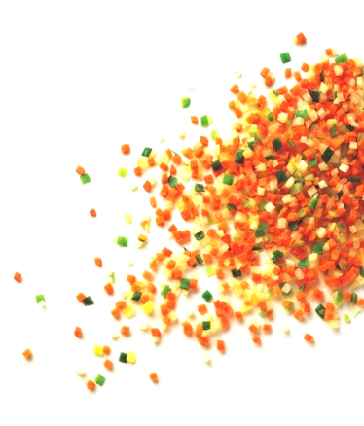**Vegetable Cuts**

**Brunoises** – Vegetables cut into small **cubes**.  Used for sautéing, a chili garnish or making garlic into a paste.

**Chiffonade** – Shredded herbs,lettuce, cabbage etc.

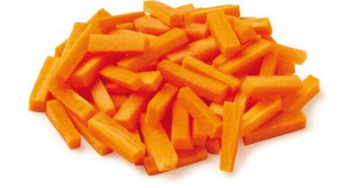

**Jardinière** – Vegetables cut into **batons**.  Idea for stir fries or a vegetable accompaniment.

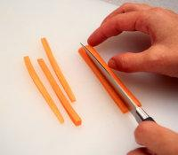  
  
  
  
  
  
**Julienne** – Thin matchsticks. Usedin stir fries or for a chili garnish.

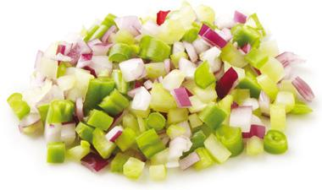  
  
  
  
  
**Macédoine** – A mixture of finely cut vegetables or fruits, sometimes jellied, and served as a salad, a dessert, or an appetizer.  Popular for curries, stews, pastries etc.

**Paysanne** – Squares, circles, triangles, semi circles. Ideal for soup.

**Carrying out the task** (30 marks)

In order to gain high marks in this section, candidates need to demonstrate:

􀁹 High standards of personal hygiene e.g. wearing of apron / whites, hair back, no nail varnish, no jewellery, etc.

􀁹 Good personal hygiene habits e.g. no licking fingers, tasting with a clean teaspoon, etc.

􀁹 Safe use of equipment, especially knives, pans and electrical equipment

􀁹 Selection of the correct tools e.g. correct knife for chopping, peeling, etc.

􀁹 Use of a wide variety of commodities within the task chosen

􀁹 Good food hygiene e.g. perishable foods refrigerated and not left on work unit / table, using temperature probes to ensure food is cooked

􀁹 Neat, organised work

􀁹 Safe use of cooker

􀁹 Working to time

􀁹 Independent working

􀁹 Good technical skills

􀁹 Little food waste

􀁹 Logical sequence of work e.g. food that needs to be cooked for a long time, be set or served cold needs to be made first

􀁹 A wide variety of skills, including high level skills

􀁹 High standard of final presentation e.g. portion control, use of garnish and decoration, good colour, correct temperature, correct texture, good flavour, appropriate serving dishes

􀁹 Good sequencing and dove-tailing of dishes so that all elements of the meal are served at the correct temperatures

􀁹 Appropriate serving of the meal

***Presenting Food***

The aim of a cook is to present food as near perfectly as possible. This involves:

• Consistency (how thin or how thick)

• Texture (includes crunchy, soft, crisp)

• Flavour (includes salty, sweet, sour, bitter, well seasoned)

• Seasoning (includes use of herbs, spices, salt and pepper)

• Colour (remember white, cream, brown and green are ‘dead’ colours)

• Decoration (used on sweet dishes – includes chocolate, cherries, fresh fruit etc

• Garnish (used on savoury dishes – includes tomato, parsley, lemon, cucumber, cress, etc.)

• Accompaniments – these include colourful vegetables and sauces.

As a general rule, do not over season, over-decorate or over fill serving dishes.

Chefs gradually learn the skills of tasting food to check for flavour, texture and seasoning.

Hot foods should be served hot and not warm, preferably on hot plates. Shaped and dramatic coloured plates can add to the overall appearance and ‘drama’ of food.

Cold food should be served cold, but not frozen and always on cold plates.

Food probes can be used to check temperatures (if available).

Savoury food is usually served in oval dishes or on oval plates if appropriate (with plain doyleys or dish papers)

Sweet food is usually served in round dishes or on round plates if appropriate (with pretty doyleys)

**Consistency:**

The consistency of food will depend on the size of pan used, the cooking time, the amount of thickener e.g. flour used and the quality of ingredients. It is easier to thin a mixture like a soup or a sauce rather than thicken it.

**Texture:**

Tasting food is essential in order to test texture. This includes checking foods like rice, pasta (cooked al dente), and vegetables to ensure they are not over-cooked.

Cooking alters the texture of food and an experienced cook will know when the right amount of heat has been applied to give the correct texture e.g. cooking steaks.

Contrasting textures are important to give variety and interest to a meal e.g. croutons with soup, wafers and ice cream, cheese and biscuits.

**Flavour and seasoning:**

Taste is very important. Good cooks know how to retain the flavour of food and how to alter the flavour of food. To retain flavour chefs need to:

• Use food as fresh as possible

• Use the least amount of cooking liquid

• Use the cooking liquid where possible (for sauces, stocks and gravies)

• Use appropriate cooking methods

• Prepare, cook and serve in as short a time as possible

• Not over-season so that customers cannot taste the natural flavour

• Use herbs and strongly flavoured foods with care

• Adjust seasoning at the end.

Examples of finished dishes:

