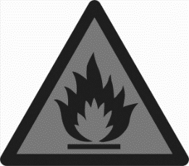
Kitchen Safety
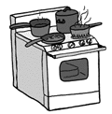
Match the picture with the kitchen hazard it represents.

SHARP OBJECTS
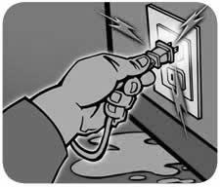
SLIPS, TRIPS AND FALLS
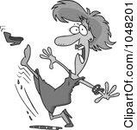
FIRE HAZARD
HOT SURFACES, LIQUIDS AND FOODS
ELECTRICAL HAZARD

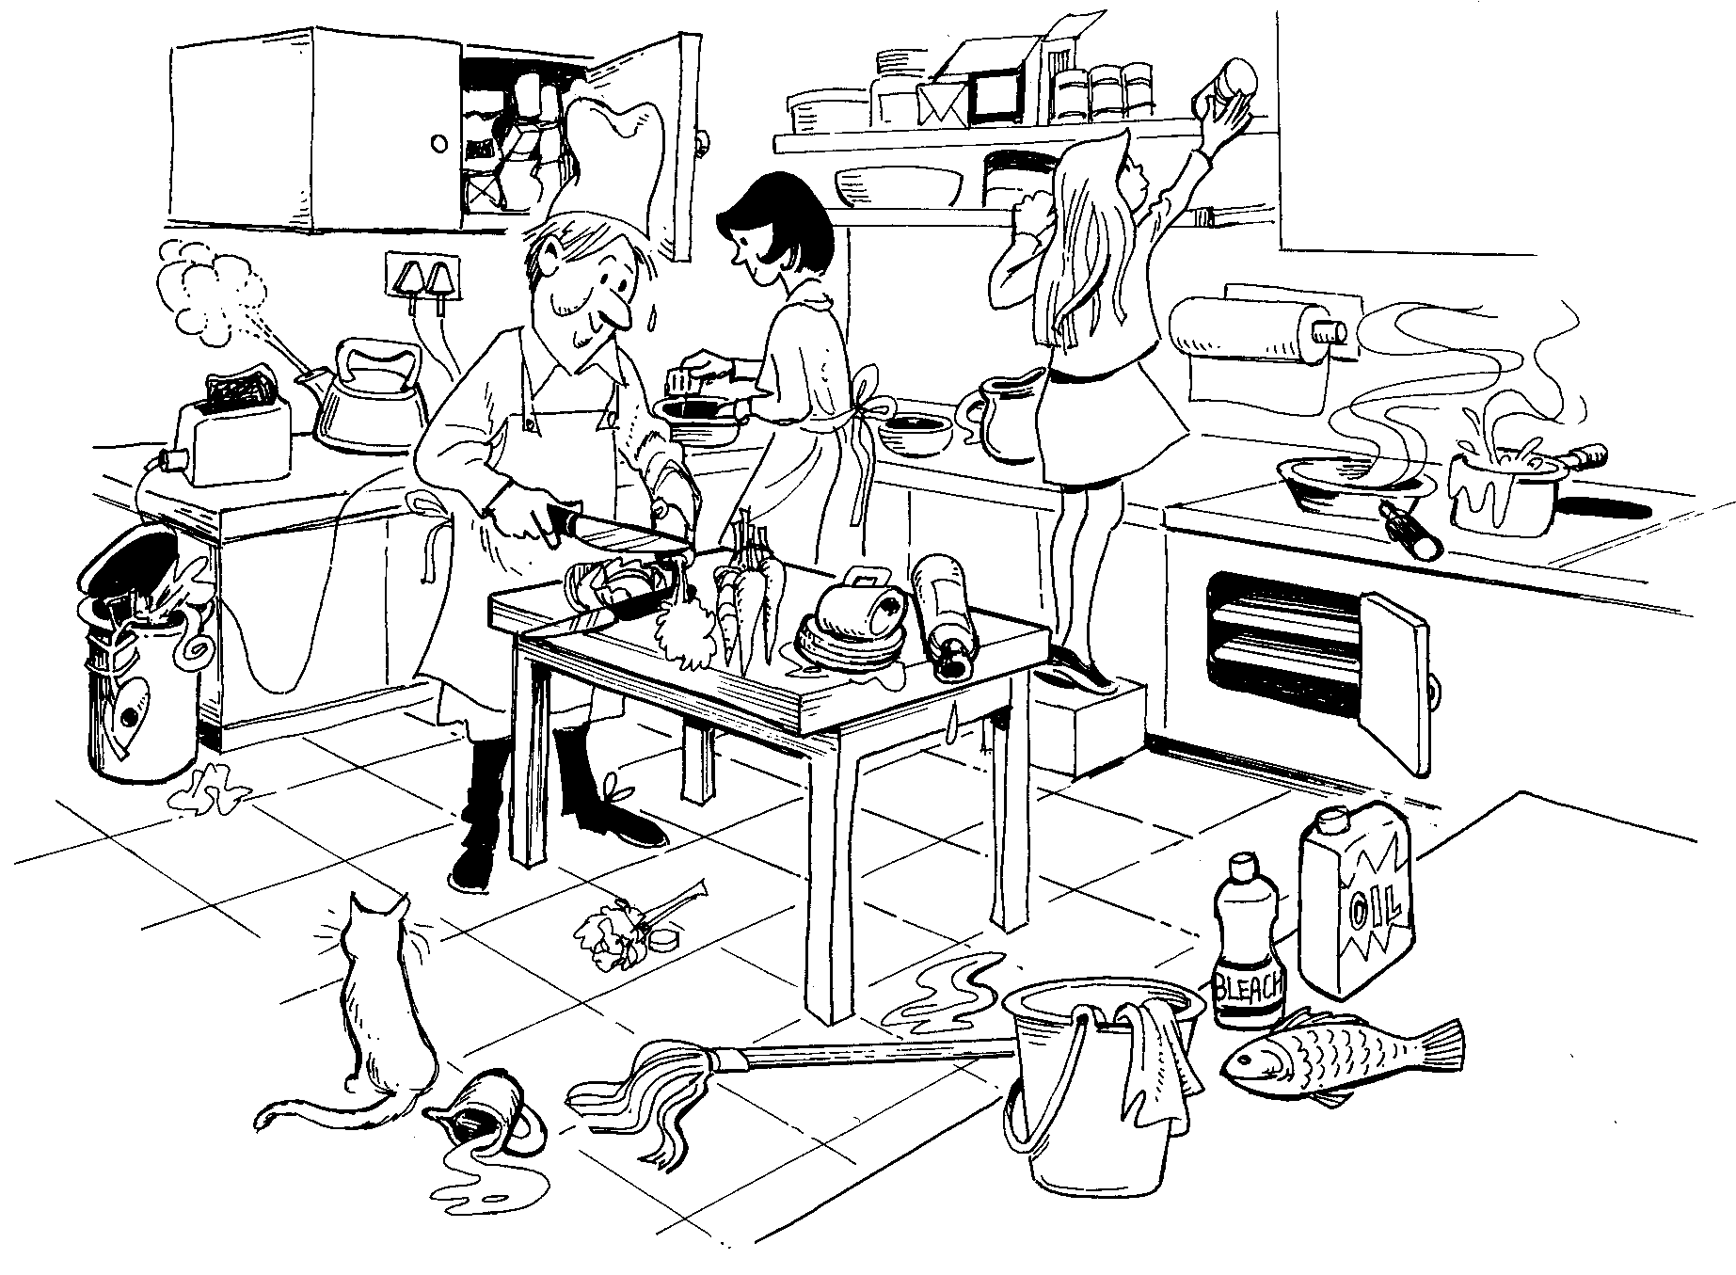
Circle the dangers in the kitchen below:

Write a list of safety rules to overcome these dangers

Kitchen Safety Wordsearch

DUST/BIN PLUGS SHARP/KNIVES WASH/HANDS COUGH
SOAPY/WATER MEDICINE EQUIPMENT CLEAN/APRON BLEACH
BLUE/PLASTER GERMS KETTLE/FLEX COOL FLIES
COVER/CUTS PETS

