
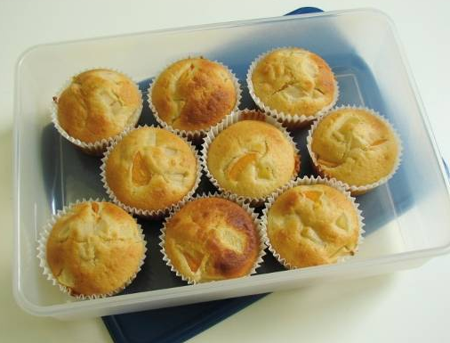

Fruity Muffins

  Ingredients | DANGERS!! Draw the safety sign where ever you need to be especially careful during the practical.
125g self raising flour  1 x 5ml spoons baking powder  50g caster sugar  100ml semi-skimmed milk  1 egg  1 tbsp oil  100g canned fruit, drained | - Gas ovens not igniting properly  - Batter is contaminated with egg shell  - Burns from hot oven
Method
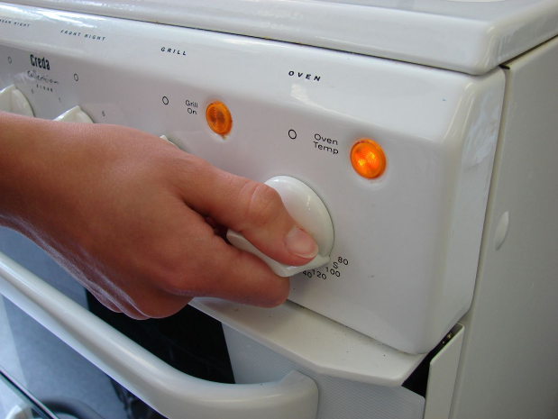  1. Preheat oven to 180°C or gas mark 4. | 2. Mix all flour, baking powder, sugar, milk, eggs and oil together to form a smooth batter.  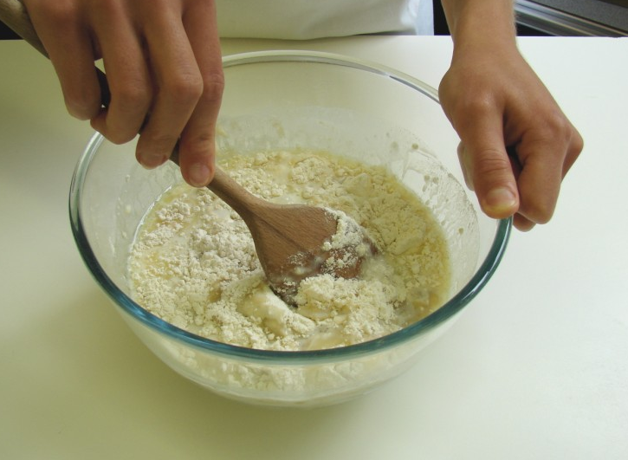
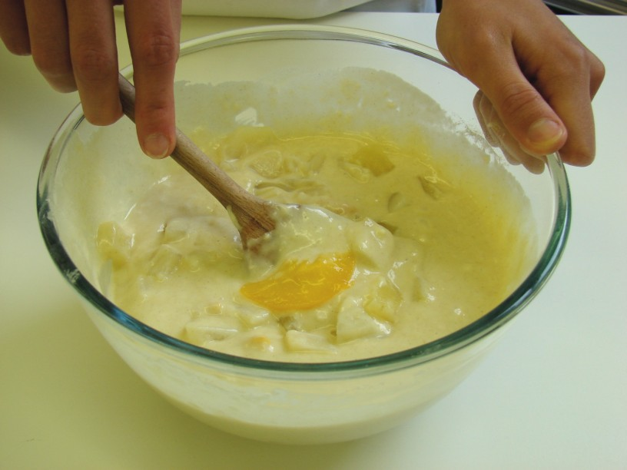  3. Stir in the fruit. | 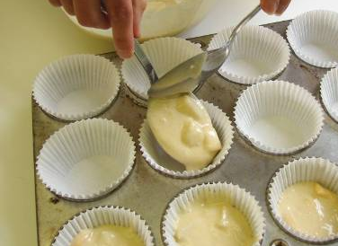  4. Divide the mixture equally between the cake cases using 2 spoons.
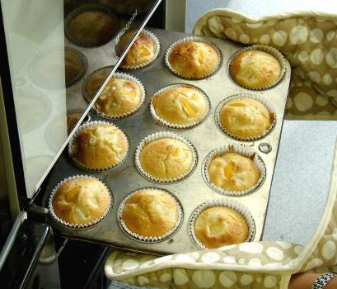  5. Bake for 20 – 25 minutes, until golden and springy to touch. | 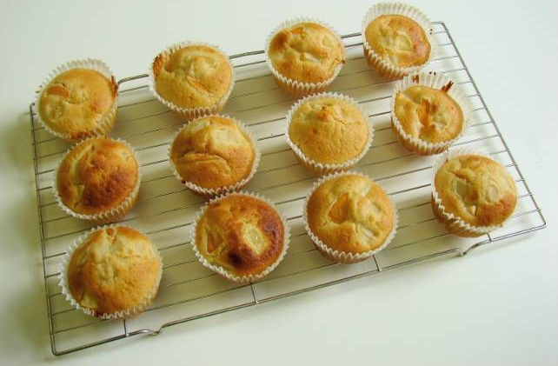  6. Allow to cool on a cooling rack.

