Fruit Crumble

Ingredients | Recipe developments | 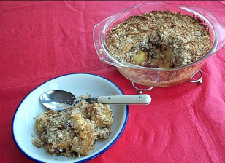  You will need to bring your fruit already prepared!! Bring an apron, a tea towel and an oven proof dish too!!
50g butter or margarine | Recipe developments
100g plain flour | Recipe developments
50g oats | Recipe developments
25g sugar | Recipe developments
500g sweetened stewed fruit… apple and sultana, blackcurrant, rhubarb | Recipe developments

Equipment
Apron, ovenproof dish, Weighing scales, mixing bowl, wooden spoon, chopping board, knife.

Method
1. Preheat the oven to 190ºC or gas mark 5.
2. Rub in the butter or margarine into the flour using your finger tips until it resembles breadcrumbs.
3. Stir in the oats and sugar.
4. Place prepared fruit in your ovenproof dish.

5. Sprinkle the crumble topping over the fruit.
6. Bake for 15-20 minutes, until the crumble is golden.

Fruit crumble risk assessment… Complete the table. Draw your at the danger spots on the method.
Risks | Control measure | Likelihood
 | Tie back long hair, remove jewellery | Med
 | Keep clicking ignition on gas oven until you can see the oven is lit. | Low
Dirty hands used for rubbing-in |  | Med
Burns from placing and removing the crumble in the oven |  | Low/Med

Top tips
My top tips for making this recipe are ...

Skills
I will be showing ...

Evaluation
Rating: (Circle) | Suitability for cafe | Likes/ Dislikes | Improvements

