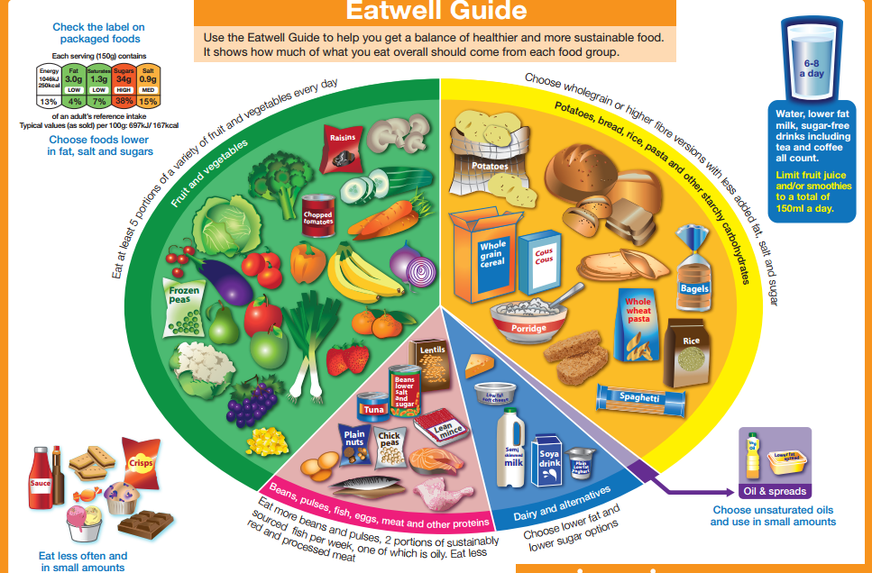
Have a look at the Eatwell guide above then use the internet to find out more about what the Eatwell guide means. Complete the table below using what you have found out from the internet:

Food group name | How much to eat | Main nutrients in this group | Functions in the body

Explain how suitable you think the eatwell guide is for teenagers in school. ______________________________________________________________________________________________________________________________________________________________________________________________ ______________________________________________________________________________________________________________________________________________________________________________________________

Name 5 other ingredients that could be added to Bolognese sauce.  1  2  3  4  5 | Tomato sauce is quite a healthy sauce because of the vegetables in it. If you added a “fatty” meat such as bacon, sausage or minced beef, what could you do to the method to keep the overall fat level as low as possible. Give reasons for you answer
Below is a stock list for tomatoes and basil from a local supermarket. Which tomatoes and basil would you choose and why?  Fresh tomatoes £1.40 for 500g  Tinned tomatoes 44p for 400g  Dried tomatoes 95p for 100g  Fresh basil 79p for about 5 tbsp  Dried basil 49p for 10 tsp | How could this sauce be used in other dishes. Try to think of at least 3 other dishes?
Find out when the foods below are in season in the UK. In which months would you be able to buy fresh UKgrown versions of these foods.

Fresh tomatoes:

Onions:

Basil:

