Chocolate Chip Cookies…
Also bring apron, tea towel and box to take cookies home
Ingredients
175g SR Flour
75 g butter (softened)
1 egg
50 g soft brown sugar
50 g caster sugar
100 g chocolate chips
The butter must be soft. The best way to achieve this is to measure out the butter an hour or so before it is needed and leave it at room temperature.
Method
Preheat the oven to 180°C / Gas Mark 4.
Line a baking tray with baking paper
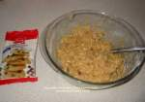 | Put the flour, butter, brown sugar and caster sugar, into a bowl and mix them well with a fork or rub in with fingers. Add the egg and chocolate chips and blend all the ingredients together.

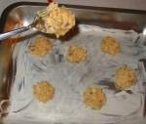 | Use a spoon to place blobs of the mixture on the baking tray. Each blob should be a little bit smaller than a golf ball.  Keep the blobs well apart because the mixture will spread out when cooking.

Place the trays in the oven and cook for 12 minutes until golden brown. Don't open the oven for at least ten minutes or you will end up with very flat cookies! Cool on the baking tray for 2 minutes then transfer them to a wire rack to cool for a further 15 minutes.

