Toastie worksheet Name ________________

Watch the Mr Bean clip http://www.youtube.com/watch?v=bS1ePEZZCDY

What things will you not do that Mr Bean does?
_________________________________________________________________________________________________________________________________________________________________________________

Using knives

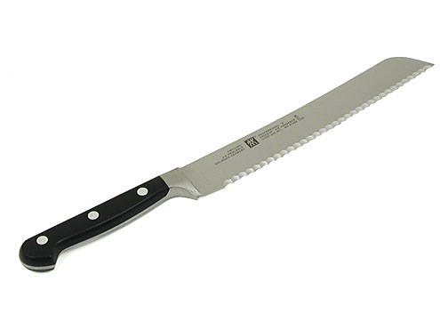 | 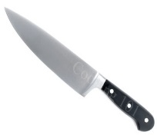 | 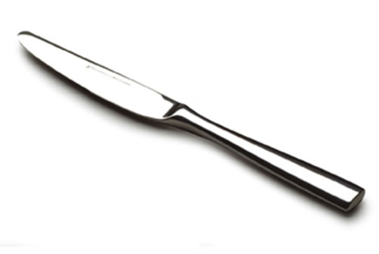
Name of knife | Name of knife | Name of knife
Used for  - __________  - __________ | Used for  - __________  - __________ | Used for  - __________  - __________

Explain 3 rules for using knives safely. Use the key words to help you.

__________________________________________________________________________________________________________________________________________________________________________________________________________________________________________________________________________________________________________________________________________________________________
Key words:
carry bridge claw watch downwards wash first
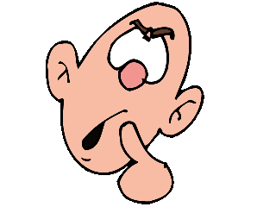
Find out and explain what to do if ........?

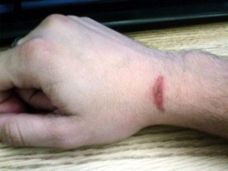  You burnt your hand  - ____________________  - ____________________  - ____________________ | Cut your finger  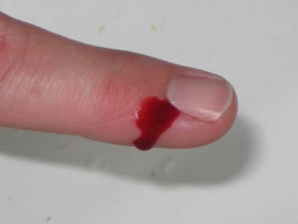  - ____________________  - ____________________  - ____________________

The basic recipe is for Cheese and Ham toastie. How will you develop or change this recipe?

My toastie recipe
_________________________________________________________________________________________________________________________________________________________________________________

1. Tick the appropriate box on the hedonic scale for your product
Hedonic scale | Like a lot | Like a little | Dislike a little | Dislike a lot
Sandwich made =

2. Describe the taste, texture and smell of your sandwich.

3. How could you improve the sandwich you made?

